**Challenge – Designing Resilient Applications**

# Context

Your Company tasks you to design the Azure footprint of a software application which is currently running on premises and has to be migrated to Azure PaaS (not lift and shift to VMs but also not rearchitecting for microservices). The application has been known to have performance issues but more importantly moments of unavailability.

So you have to consider not only how the application will run in Azure, but also how it is designed for reliability in the context of your enterpise.

This is a simplistic diagram of the current, on premises architecture, consisting of:

* A frontend layer, ASP.NET Core web application running on a Windows Server / IIS
* A middleware (processing) layer, Windows Service
* A backend, SQL Server

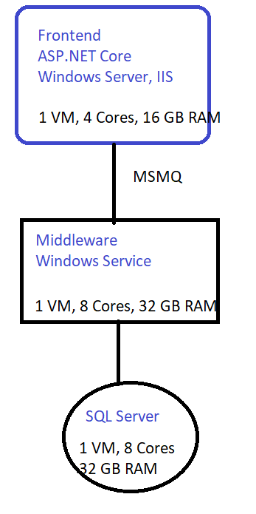

# The challenge

Design a reliable architecture (do a diagram) in Azure for this software application, using PaaS services. Make sure there is no single point of failure, and no individual component (frontend, middleware, backend) can be unavailable. Consider the risk of a Region unavailability: we don’t want to have a full live secondary deployment in a secondary region but be able to failover quickly. Explain how.

Explain which are the RTO and RPO that this architecture can sustain.